Endangered Species Homework Assignment

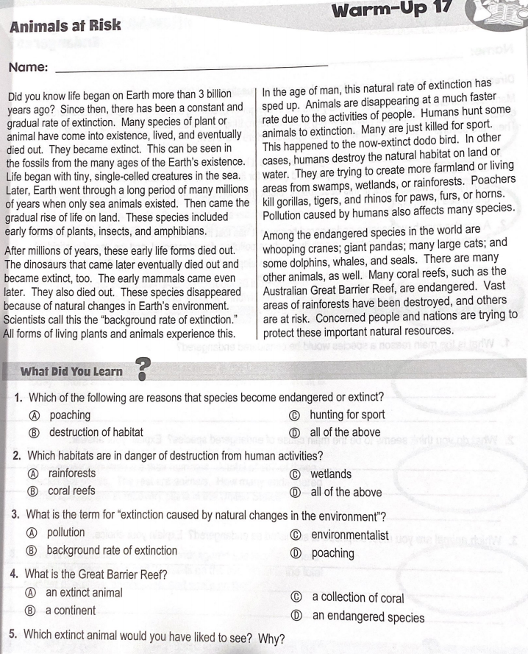

Please write your answers from the above worksheet below

1- D

2- D

3- B

4- D

5- I would have liked to see a dinosaur because the pictures I have seen are very cool. Also it is a species that no one has got to meet so I would like to meet it.

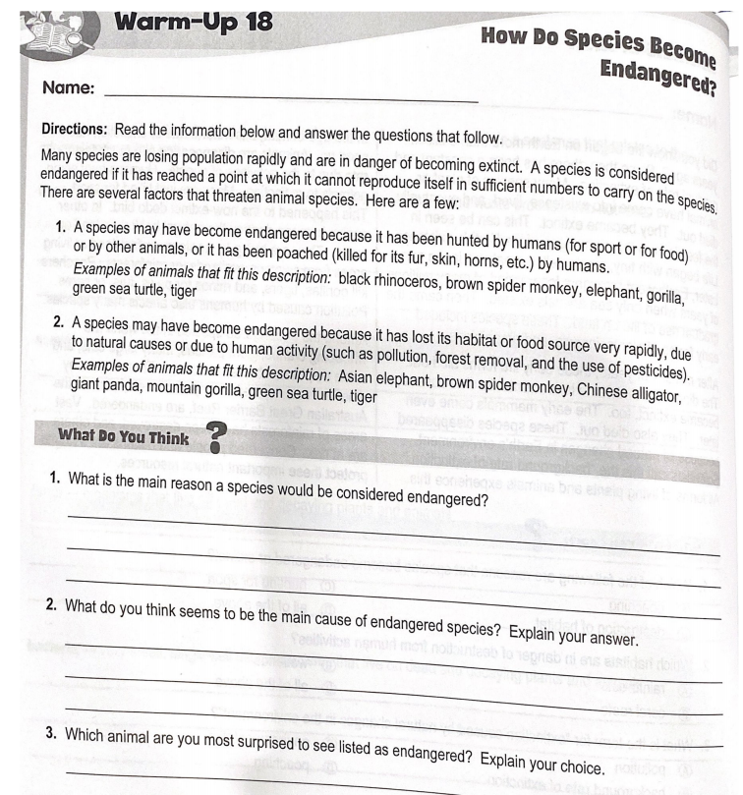

Please write your answers from the above worksheet below

1- The main reason a species could be considered endangered is loss of habitat.

2- I think the main cause of endangered species is killing animals. I think this because a lot of people kill animals for a sport, fun, or they just want to. But mainly they kill animals to get meat and money.

3- I am most surprised to see the chinese alligator listed because as far as I know no one shoots alligators and no one can see shoot an alligator underwater.